Woodward, Ryan

V00857268

STAT 260 R-Assignment 1

Instructor: C. Barone

**Part 1:**

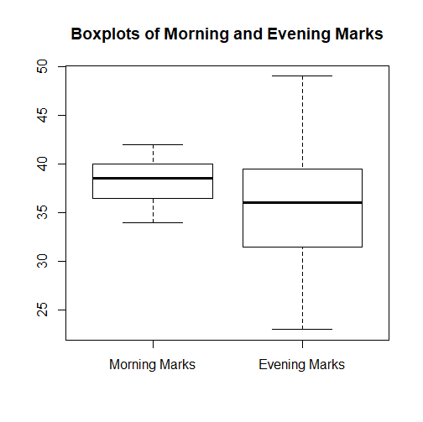

**Part 2:**

**Morning Marks**

> mean(morning.marks)

[1] 38.225

> sd(morning.marks)

[1] 2.189573

**Evening Marks**

> mean(evening.marks)

[1] 36

> sd(evening.marks)

[1] 6.164414

**Part 3:**

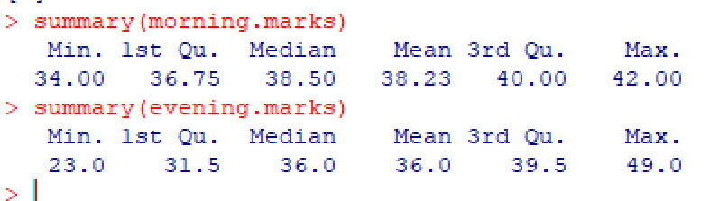

When we analyze both boxplots of the morning and evening marks we see the there is a much greater spread in the evening marks of the students. We can see also that the morning marks box is higher than the evening marks box. This also suggests that the morning section had overall better midterm marks. If we analyze the whiskers of the evening marks box we see that the mean could perhaps be skewed due to the fact of the length of those whiskers. However since the whiskers extend in either direction of the box the skewness seems to cancel each other out. This is represented in the fact that the medians of both morning and evening are similar. We can conclude that since the box is higher, the mean is higher, and the standard deviation lower, that overall the morning section have done better on the exam.